Experiment No. 06
1. Write a program to create a dictionary of student details.
student = {}
student["name"] = input("Enter name: ")
student["roll_no"] = input("Enter roll number: ")
student["age"] = int(input("Enter age: "))
student["course"] = input("Enter course: ")
student["marks"] = float(input("Enter marks: "))
print("\n--- Student Details ---")
print(student)
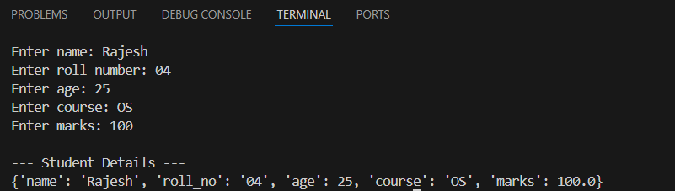

2. Write a program to access keys, values and items of a dictionary.
student = {
"name": "John",
"age": 20,
"course": "BSc"
}
print("Keys:", student.keys())
print("Values:", student.values())
print("Items:", student.items())
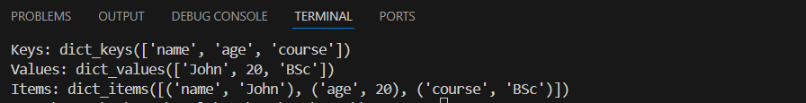

3. Write a program to add and update dictionary elements.
student = {
"name": "John",
"age": 20
}
# Add new element
student["course"] = "BSc"
# Update existing element
student["age"] = 21
print(student)

4. Write a program to delete elements from dictionary.
student = {
"name": "John",
"age": 20,
"course": "BSc"
}
del student["age"]
print(student)
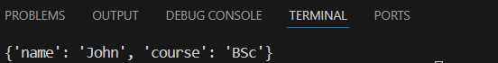

5. Write a program to count frequency of words in a sentence using dictionary.
sentence = input("Enter a sentence: ")

words = sentence.split()
freq = {}
for word in words:
if word in freq:
freq[word] += 1
else:
freq[word] = 1
print("\nWord Frequency:")
print(freq)
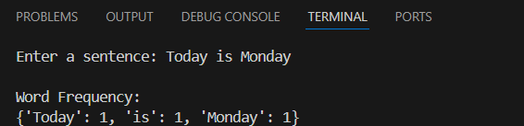

6. Write a program to merge two dictionaries.
d1 = {"a": 1, "b": 2}
d2 = {"c": 3, "d": 4}
d1.update(d2)
print(d1)
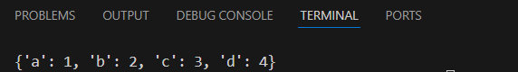

7. Write a program to convert hexadecimal to binary using dictionary.
hex_bin = {
'0': '0000', '1': '0001', '2': '0010', '3': '0011',
'4': '0100', '5': '0101', '6': '0110', '7': '0111',
'8': '1000', '9': '1001', 'A': '1010', 'B': '1011',
'C': '1100', 'D': '1101', 'E': '1110', 'F': '1111'
}
hex_num = input("Enter hexadecimal number: ").upper()
binary = ""
for digit in hex_num:
if digit in hex_bin:
binary += hex_bin[digit]
else:
print("Invalid hexadecimal digit")
break
print("Binary value:", binary)
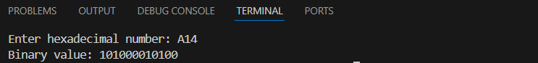

8. Write a program to find student with highest marks.
students = {
"John": 75,
"Alice": 88,
"Bob": 92,
"Emma": 85
}

top_student = max(students, key=students.get)
print("Student with highest marks:", top_student)
print("Marks:", students[top_student])
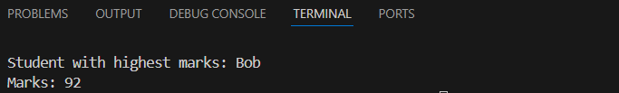

9. Write a program to sort dictionary by keys and values.
d = {}
n = int(input("Enter number of elements: "))
for i in range(n):
k = input("Enter key: ")
v = int(input("Enter value: "))
d[k] = v
# Sort by keys
by_keys = dict(sorted(d.items()))
# Sort by values
by_values = dict(sorted(d.items(), key=lambda x: x[1]))
print("\nOriginal Dictionary:", d)
print("Sorted by Keys:", by_keys)
print("Sorted by Values:", by_values)
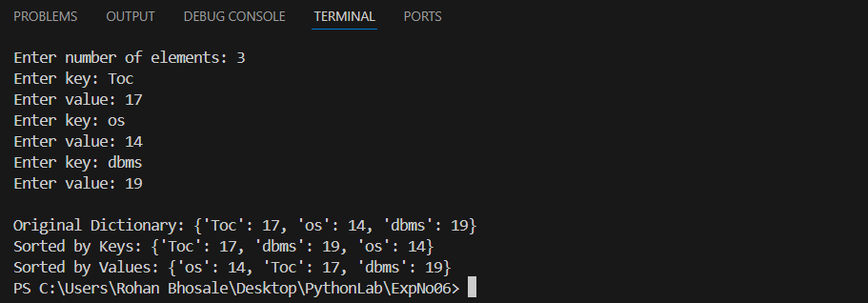

10. Write a program to demonstrate dictionary comprehension.
n = int(input("Enter range: "))
squares = {x: x*x for x in range(1, n+1)}
print(squares)

